PERSONAL TRAINER
Student’s Name

Code+ Course Name
Professor’s Name
University’s Name
City, State
Date

Question 1
The career plan of a person is reliant on the values, skills, and the interests one develops towards that chosen career. In my cases as a personal trainer, there are unique values, skills, and interests that have been established from the self-awareness audit. When it comes to areas of interests, social, enterprising, and conventional are my areas of interests. Social reflects with interactions with other people and how being a personal trainer deals with interacting with people from a diverse background (Barnes 2016, p.40). The interest in social behavior fits my career as I provide professional services that help individuals improve their physical fitness. Enterprising is an interest in spotting opportunities form the things we like. As a personal trainer, I believe that I can develop a business idea that will help me generate income at the same time helping the people in need of fitness. The last interest is conventional, which means that I have to align my activities to expected norms and behavior in society. In my career, I should act within the confines of society and only focus on physical fitness.
When it comes to career values, the self-assessment audit indicates that I am a person who values autonomy, enterprise, and expertise. Autonomy reflects on being independent and making independent decisions. A personal trainer should be a person who is autonomous by acting independently without coercion or any external influence (Corbin 2018, n.p). Enterprise reflects on making a career a business, and personal training offers enormous opportunities in different sectors. The career demands that one is skilled, and this is where the value of expertise is required. An expert personal trainer can attract more clients and benefit economically from the services rendered.
I have several likes but training others, networking, and mentoring others are the skills that I can showcase better. As a personal trainer, I should be able to train other people to be able to achieve the desired levels of fitness and also engage in routine exercise without any supervision. Besides, I should be able to mentor others to develop a liking for personal training and also help other people to be fitness enthusiasts. The last skill is networking, which means that one should establish networks that facilitate the sharing of ideas and opportunities (Barnes 2017, p.190). These skills are important in the career of personal training in fostering a healthy society that have positive attitudes towards physical exercise and achieving desired levels of fitness.
Question 2
The self-assessment audit provided the skills, interests, and values that are suited to my career as a personal trainer. A personal trainer is a career that demands one to have an interest in developing a social relationship with clients and society. The social interest, as identified in the audit, is critical for my career as it helps in networking and promoting professionalism within the career (De Lyon 2017, p.320). The routine of a personal trainer can involve visiting organizations and sensitizing employees on the need to stay fit. Besides, the activity provides the perfect opportunity to socialize and sell the enterprising idea that will persuade the target group to seek the services of the personal trainer. One of the job descriptions of a personal trainer is to demonstrate routines and exercises to clients and this is something that will match social interests. Personal training can best be enhanced through networking, where clients refer to another fitness enthusiast to join a fitness program designed and developed to promote wellness in society. a personal trainer provides information on fitness resources that improves networking. The skill of mentorship comes in handy in influencing the attitudes of individuals who join the program to be consistent in fitness practices. As such a personal trainer must monitor the progress of a client while providing the right mentorship.
The career path of personal training is enterprising, particularly in the sporting sector. There is an increasing demand for athletes and other sports personalities to engage in regular training programs. As a personal trainer, one can be hired to take over the training of an athlete to improve their performances in sporting activities (Sekendiz 2014, p.10). This is the point where both the interests and values of the enterprise match the career of personal training. As a personal trainer, one is required to be assist clients in exercises to minimize cases of injures and promote fitness levels. In pursuit of developing a competitive enterprise, expert knowledge and service are required to develop a competitive edge and preference towards the services offered by the personal trainer (Thompson 2017, p.17). As such, the trainer must modify fitness programs to match the level of fitness of the client. In all this, the autonomy of making decisions is required while conforming with conventional expectations of a personal training career. These skills and interests are applied interchangeably to get the best of the career.
Question 3
Personal training is a career that is related to growth, development, and aging. The self-awareness audit identified the skills, interests, and values that support the science of growth development and aging. During growth, a personal trainer can help in designing the right fitness programs for children and teens, which promotes health. The growth of children demands that they engage in regular physical exercises that prevent them from developing health issues such as obesity. During the growth phase of a person, the skills of mentoring and conventional interests are required to help children follow a growth path that is suited for their future development. A personal trainer should be able to understand children and make changes to personal training, particularly to children that show sporting talents (Harvey 2014, p.460). When it comes to the developmental stage, a personal trainer has a lot to do to help individuals who are at the development stage. It is during this stage that a person easily develops lifestyle diseases. As such, the skill of networking and mentorship is required to get people to engage in physical fitness. Besides, social interest develops where one can engage different individuals who are looking for avenues to improve their fitness (Kettunen 2018, n.p). Besides, at the developmental stage, the interests of entrepreneurship develop where a personal trainer can develop a business that exclusively provides for the fitness needs of individuals. At the aging phase, personal trainers help the aging population to cope with health challenges that accompany aging. At this stage, expert skill is required to identify the kind of needs required by the aging population (Schmidt 2015, p.1065). Entrepreneurial interest becomes important as the trainer exploit opportunities that present themselves while helping the elderly to cope with old age. Besides, mentorship and networking become critical at this point in life.

Bibliography
Barnes, K., Desbrow, B. and Ball, L., 2016. Personal trainers are confident in their ability to provide nutrition care: a cross-sectional investigation. Public health, 140, pp.39-44.
Barnes, K., Ball, L. and Desbrow, B., 2017. Personal trainer perceptions of providing nutrition care to clients: a qualitative exploration. International journal of sport nutrition and exercise metabolism, 27(2), pp.186-193.
Corbin, C.B. and Le Masurier, G., 2018. Fitness for life. Human Kinetics.
De Lyon, A.T., Neville, R.D. and Armour, K.M., 2017. The role of fitness professionals in public health: a review of the literature. Quest, 69(3), pp.313-330.
Harvey, G., Vachhani, S.J. and Williams, K., 2014. Working out: aesthetic labour, affect and the fitness industry personal trainer. Leisure studies, 33(5), pp.454-470.
Kettunen, E. and Kari, T., 2018. Can Sport and Wellness Technology be My Personal Trainer? Teenagers and Digital Coaching. In Bled eConference. University of Maribor Press.
Schmidt, B., Benchea, S., Eichin, R. and Meurisch, C., 2015, September. Fitness tracker or digital personal coach: how to personalize training. In Adjunct Proceedings of the 2015 ACM International Joint Conference on Pervasive and Ubiquitous Computing and Proceedings of the 2015 ACM International Symposium on Wearable Computers (pp. 1063-1067). ACM.
Sekendiz, B., 2014. Personal fitness trainers giving tough love: Risks and consequences. ACSM's Health & Fitness Journal, 18(3), pp.8-11.
Thompson, W.R., 2017. Worldwide survey of fitness trends for 2018: the CREP edition. ACSM's Health & Fitness Journal, 21(6), pp.10-19.

Appendix
Job Description
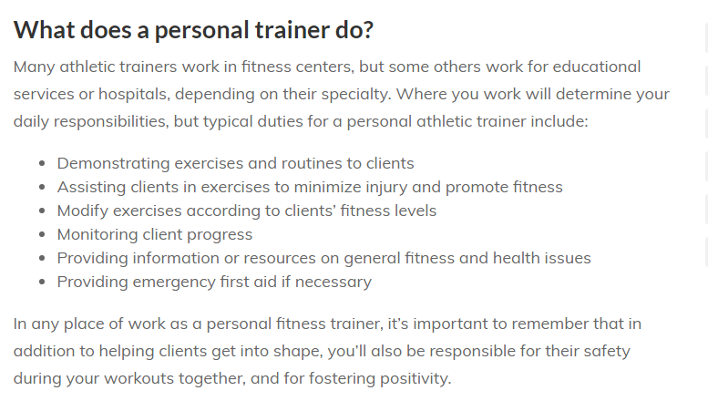
https://www.naturalhealers.com/personal-training/job-description/

